SIMATS ENGINEERING

CSA4307
INTERNET PROGRAMMING

CO2 - ASSESSMENT TOOL 2

Bavani Sri M (192311405)

Code of Conduct
I Bavani Sri M (192311405) that this submission is my original work and that I have adhered to the guidelines specified for this assessment. I understand that any violation of academic integrity rules will result in disciplinary action.
Signature of the student: Bavani Sri M

Question 1: Responsive Navigation Bar Design
Suppose that an e-commerce website requires a responsive navigation bar that adapts across desktop, tablet, and mobile devices.

(a) Identify key components required in a navigation bar for an e-commerce website.
A navigation bar helps customers move around an online store. Its important components are:
1. Logo or brand name: identifies the store and links to the home page.
2. Home: returns users to the main page.
3. Product categories: groups products such as clothing, books, electronics, and accessories.
4. Search bar: helps customers find products by name or keyword.
5. Offers: highlights discounts and seasonal promotions.
6. Shopping cart: shows selected items and provides access to checkout.
7. Account: allows users to sign in, register, and view orders.
8. Wishlist: stores products the customer may wish to buy later.
9. Responsive menu button: makes navigation links available on small screens.
The exact components depend on the store’s purpose. Important actions such as search and cart access should be easy to find.

(b) Design a responsive navigation bar using appropriate CSS techniques.
Flexbox aligns the logo and navigation links. A media query changes the layout on smaller screens, and JavaScript toggles the mobile menu.

Program
<!DOCTYPE html>
<html lang="en">
<head>
<meta charset="UTF-8">
<meta name="viewport" content="width=device-width, initial-scale=1.0">
<title>Responsive Navigation</title>
<style>
body { margin: 0; font-family: Arial, sans-serif; }
.navbar { display: flex; justify-content: space-between; align-items: center;
background: #1e293b; color: white; padding: 15px 5%; }
.logo { font-size: 24px; font-weight: bold; }
.nav-links { display: flex; gap: 15px; }
.nav-links a { color: white; text-decoration: none; padding: 10px; }
.nav-links a:hover, .nav-links a:focus { background: #475569; border-radius: 4px; }
.menu-btn { display: none; font-size: 24px; color: white;
background: none; border: none; cursor: pointer; }
@media (max-width: 768px) {
.navbar { position: relative; }
.menu-btn { display: block; }
.nav-links { display: none; flex-direction: column; gap: 4px;
position: absolute; top: 100%; left: 0; width: 100%;
padding: 12px; box-sizing: border-box; background: #1e293b; z-index: 5; }
.nav-links.active { display: flex; }
}
</style>
</head>
<body>
<header class="navbar">
<div class="logo">ShopEasy</div>
<button class="menu-btn" id="menuBtn" aria-expanded="false"
aria-controls="navLinks" aria-label="Toggle navigation">☰</button>
<nav class="nav-links" id="navLinks">
<a href="#home">Home</a><a href="#products">Products</a>
<a href="#offers">Offers</a><a href="#cart">Cart</a><a href="#account">Account</a>
</nav>
</header>
<main id="home"><h1>Welcome to ShopEasy</h1><p>Find products and offers in one place.</p></main>
<script>
const menuBtn = document.getElementById("menuBtn");
const navLinks = document.getElementById("navLinks");
menuBtn.addEventListener("click", function () {
const isOpen = navLinks.classList.toggle("active");
menuBtn.setAttribute("aria-expanded", String(isOpen));
});
</script>
</body>
</html>

Code explanation
- Flexbox aligns the logo and links.
- The media query changes the navigation for narrow screens.
- JavaScript toggles the active class when the button is clicked.
- aria-expanded communicates the menu state to assistive technology.
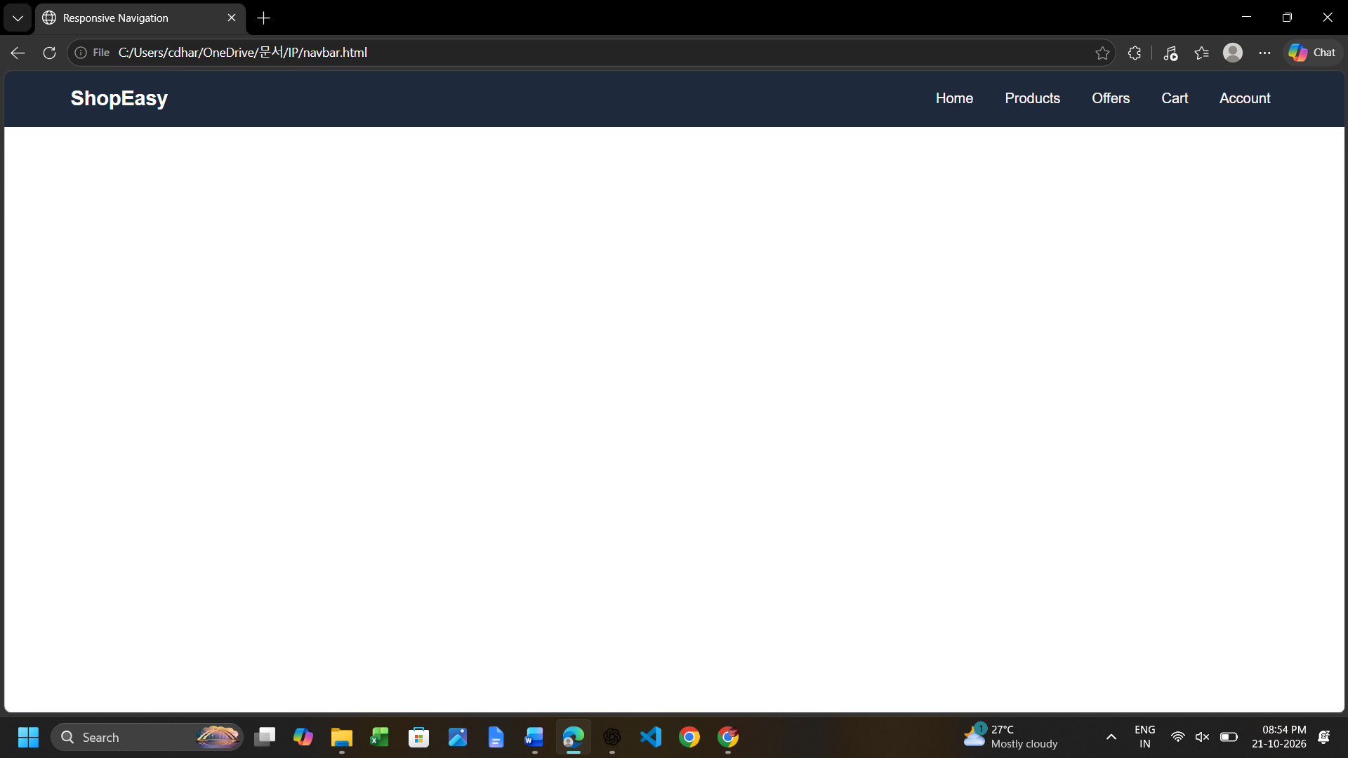

(c) Demonstrate how the navigation adapts to smaller screens.
Desktop: links appear in one horizontal row and the hamburger button is hidden.
Tablet: the breakpoint determines whether links remain horizontal or switch to the compact menu.
Mobile: links are initially hidden and a hamburger button appears. Clicking it reveals the links vertically. Clicking it again hides them.
The viewport meta tag allows the browser to use the device width. The CSS media query handles layout changes; JavaScript handles the open/closed state.
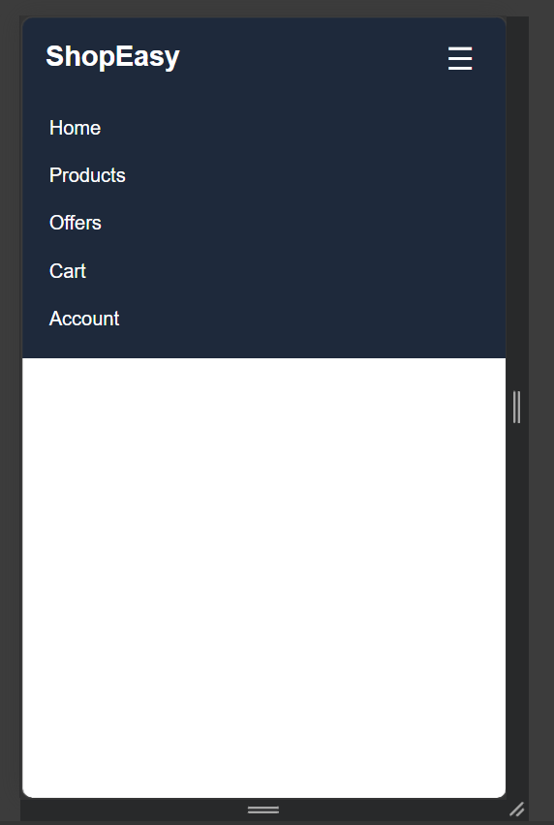

(d) Evaluate the usability and suggest improvements for better user experience.
A responsive navigation bar reduces clutter on small displays and maintains consistent navigation across devices. Improve it by using clear labels, sufficient touch target sizes, visible hover and keyboard-focus styles, and an accessible expanded/collapsed state. Search and cart links should be easy to locate. Test on different screen widths and with keyboard navigation. Avoid excessive animation and ensure the menu does not cover important content unexpectedly.

Expected Output
Desktop displays links horizontally. On mobile, the ☰ button opens and closes the vertical navigation menu.

Result
The required webpage design and interaction are implemented using HTML, CSS, and JavaScript. The result demonstrates responsive behaviour, clear visual feedback, and appropriate usability considerations for the given scenario.

Question 2: Product Hover Effect –
Suppose that an e-commerce website wants to enhance user interaction through visual effects on product items.

(a) Identify suitable CSS properties for hover effects.
The :hover pseudo-class applies styles when a pointer is placed over an element. Useful properties include transform to move or scale a card, transition to make changes smooth, box-shadow to create depth, background-color and color to show feedback, opacity to change transparency, border to highlight an item, and filter to adjust image brightness. The :focus-visible selector can provide similar feedback to keyboard users.

(b) Suggest appropriate CSS animation or transition for product interaction.
A short transition is suitable for a product card. For example, transition: transform 0.3s ease, box-shadow 0.3s ease makes movement and shadow changes smooth. translateY(-8px) lifts the card, while scale(1.03) enlarges it slightly. A duration around 0.2–0.3 seconds is usually fast enough to feel responsive. Avoid excessive bouncing or long animations because they can distract customers.

(c) Design a hover effect for a product card.
The following program creates three product cards. Hovering over a card lifts it slightly and strengthens its shadow.

Program
<!DOCTYPE html>
<html lang="en">
<head>
<meta charset="UTF-8">
<meta name="viewport" content="width=device-width, initial-scale=1.0">
<title>Product Hover Effect</title>
<style>
body { font-family: Arial, sans-serif; margin: 0; padding: 25px;
background: #f1f5f9; text-align: center; }
.products { display: flex; justify-content: center; flex-wrap: wrap; gap: 20px; }
.card { width: 210px; padding: 20px; background: white; border-radius: 10px;
box-shadow: 0 2px 8px #0002;
transition: transform .3s ease, box-shadow .3s ease; }
.card:hover { transform: translateY(-8px) scale(1.03); box-shadow: 0 8px 18px #0003; }
.icon { font-size: 48px; }
.price { color: #0f766e; font-weight: bold; }
button { background: #1e293b; color: white; border: 0; padding: 10px 14px;
border-radius: 5px; cursor: pointer; }
button:hover, button:focus-visible { background: #334155; }
.card:focus-within { outline: 2px solid #2563eb; }
@media (prefers-reduced-motion: reduce) {
.card { transition: none; }
}
</style>
</head>
<body>
<h1>Featured Products</h1>
<div class="products">
<article class="card"><div class="icon">🎧</div><h2>Headphones</h2>
<p class="price">₹1,499</p><button type="button">View Product</button></article>
<article class="card"><div class="icon">⌚</div><h2>Smart Watch</h2>
<p class="price">₹2,999</p><button type="button">View Product</button></article>
<article class="card"><div class="icon">🎒</div><h2>Backpack</h2>
<p class="price">₹899</p><button type="button">View Product</button></article>
</div>
</body>
</html>

Code explanation
- The products container uses Flexbox and flex-wrap.
- The transition property creates smooth movement.
- The hover selector applies the raised-card effect.
- The reduced-motion media query avoids unnecessary motion for users who request reduced motion.
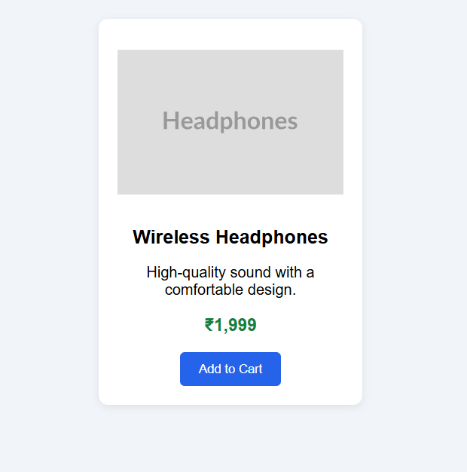
Before hover effect
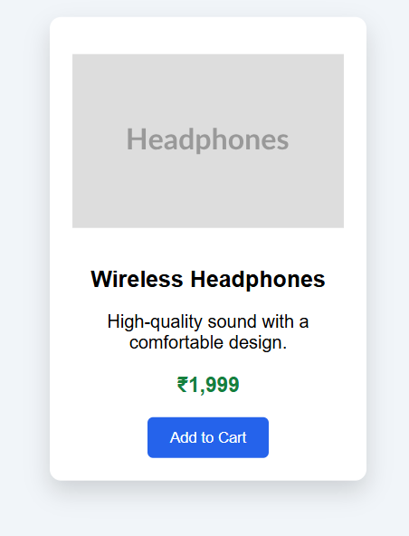
After hover effect

(d) Evaluate performance and user experience considerations.
Prefer animating transform and opacity because they generally perform smoothly. Avoid animating many expensive layout properties across a large catalogue. Keep text and prices readable, preserve enough spacing between cards, and ensure that essential information is not available only through hover because touchscreens may not have hover. Use keyboard focus styles and respect reduced-motion preferences when animations are more substantial. A hover effect is visual feedback; the button needs a link or JavaScript if it must perform a real shopping action.

Expected Output
Three product cards are shown. Moving the pointer over a card raises it and adds a stronger shadow; moving away returns it to normal. The button has a separate hover/focus effect.

Result
The required webpage design and interaction are implemented using HTML, CSS, and JavaScript. The result demonstrates responsive behaviour, clear visual feedback, and appropriate usability considerations for the given scenario.

Question 3: Layout Selection (Flexbox vs Grid) –
Suppose that a dashboard layout needs to be designed for a web application.

(a) Identify layout requirements of a dashboard (rows, columns, alignment).
A dashboard commonly contains a header, sidebar, summary cards, charts, tables, and activity panels. Requirements include aligning components, arranging information into rows and columns, keeping spacing consistent, resizing panels for different screens, and preserving a clear visual hierarchy. Some components must line up in one direction, while the whole dashboard often needs a two-dimensional structure.

(b) Compare Flexbox and Grid based on layout needs.
Flexbox is primarily one-dimensional and arranges items along a row or column. It is useful for navigation bars, toolbars, button groups, and aligning content within a component. Grid is two-dimensional and manages rows and columns together. It is suitable for dashboard cards, chart panels, and complex page structures. Flexbox offers convenient distribution along one axis; Grid offers explicit control over both axes. They can be used together.
CSS Grid is generally the best choice for the main dashboard because dashboards commonly require several rows and columns. grid-template-columns defines the columns, gap provides consistent spacing, and media queries can reduce the number of columns on smaller screens. Flexbox can still be used inside each card to align its title, icon, and value.

(c) Choose the most suitable layout technique and justify your choice.
CSS Grid is generally the best choice for the main dashboard because dashboards commonly require several rows and columns. grid-template-columns defines the columns, gap provides consistent spacing, and media queries can reduce the number of columns on smaller screens. Flexbox can still be used inside each card to align its title, icon, and value.
A dashboard commonly contains a header, sidebar, summary cards, charts, tables, and activity panels. Requirements include aligning components, arranging information into rows and columns, keeping spacing consistent, resizing panels for different screens, and preserving a clear visual hierarchy. Some components must line up in one direction, while the whole dashboard often needs a two-dimensional structure.

Program
<!DOCTYPE html>
<html lang="en">
<head>
<meta charset="UTF-8">
<meta name="viewport" content="width=device-width, initial-scale=1.0">
<title>Dashboard Layout</title>
<style>
body { margin: 0; padding: 20px; font-family: Arial, sans-serif; background: #f8fafc; }
h1 { text-align: center; }
.dashboard { display: grid; grid-template-columns: repeat(3, minmax(0, 1fr)); gap: 15px; }
.panel { background: #dbeafe; padding: 25px; border-radius: 8px; text-align: center; }
.panel.wide { grid-column: span 2; background: #dcfce7; }
@media (max-width: 800px) {
.dashboard { grid-template-columns: repeat(2, minmax(0, 1fr)); }
.panel.wide { grid-column: span 2; }
}
@media (max-width: 500px) {
.dashboard { grid-template-columns: 1fr; }
.panel.wide { grid-column: span 1; }
}
</style>
</head>
<body>
<h1>Sales Dashboard</h1>
<main class="dashboard">
<section class="panel"><h2>Sales</h2><p>₹45,000</p></section>
<section class="panel"><h2>Orders</h2><p>128</p></section>
<section class="panel"><h2>Customers</h2><p>86</p></section>
<section class="panel wide"><h2>Monthly Performance</h2><p>Chart area</p></section>
<section class="panel"><h2>Recent Activity</h2><p>Latest updates</p></section>
</main>
</body>
</html>

Code explanation
- CSS Grid creates the dashboard rows and columns.
- minmax(0, 1fr) helps columns shrink within the available width.
- The wide panel spans two columns on larger screens.
- Media queries switch to two and then one column.

(d) Evaluate the scalability and responsiveness of the chosen approach.
Grid scales well when more dashboard panels are added. Use repeat() and minmax() to create flexible tracks, and media queries to change the number of columns for tablets and phones. Avoid fixed widths that cause horizontal scrolling. For a small screen, a multi-column dashboard can become a single-column stack. Test charts and tables separately because their content may need additional responsive handling.

Code explanation
- CSS Grid creates the dashboard rows and columns.
- minmax(0, 1fr) helps columns shrink within the available width.
- The wide panel spans two columns on larger screens.
- Media queries switch to two and then one column.
A dashboard commonly contains a header, sidebar, summary cards, charts, tables, and activity panels. Requirements include aligning components, arranging information into rows and columns, keeping spacing consistent, resizing panels for different screens, and preserving a clear visual hierarchy. Some components must line up in one direction, while the whole dashboard often needs a two-dimensional structure.

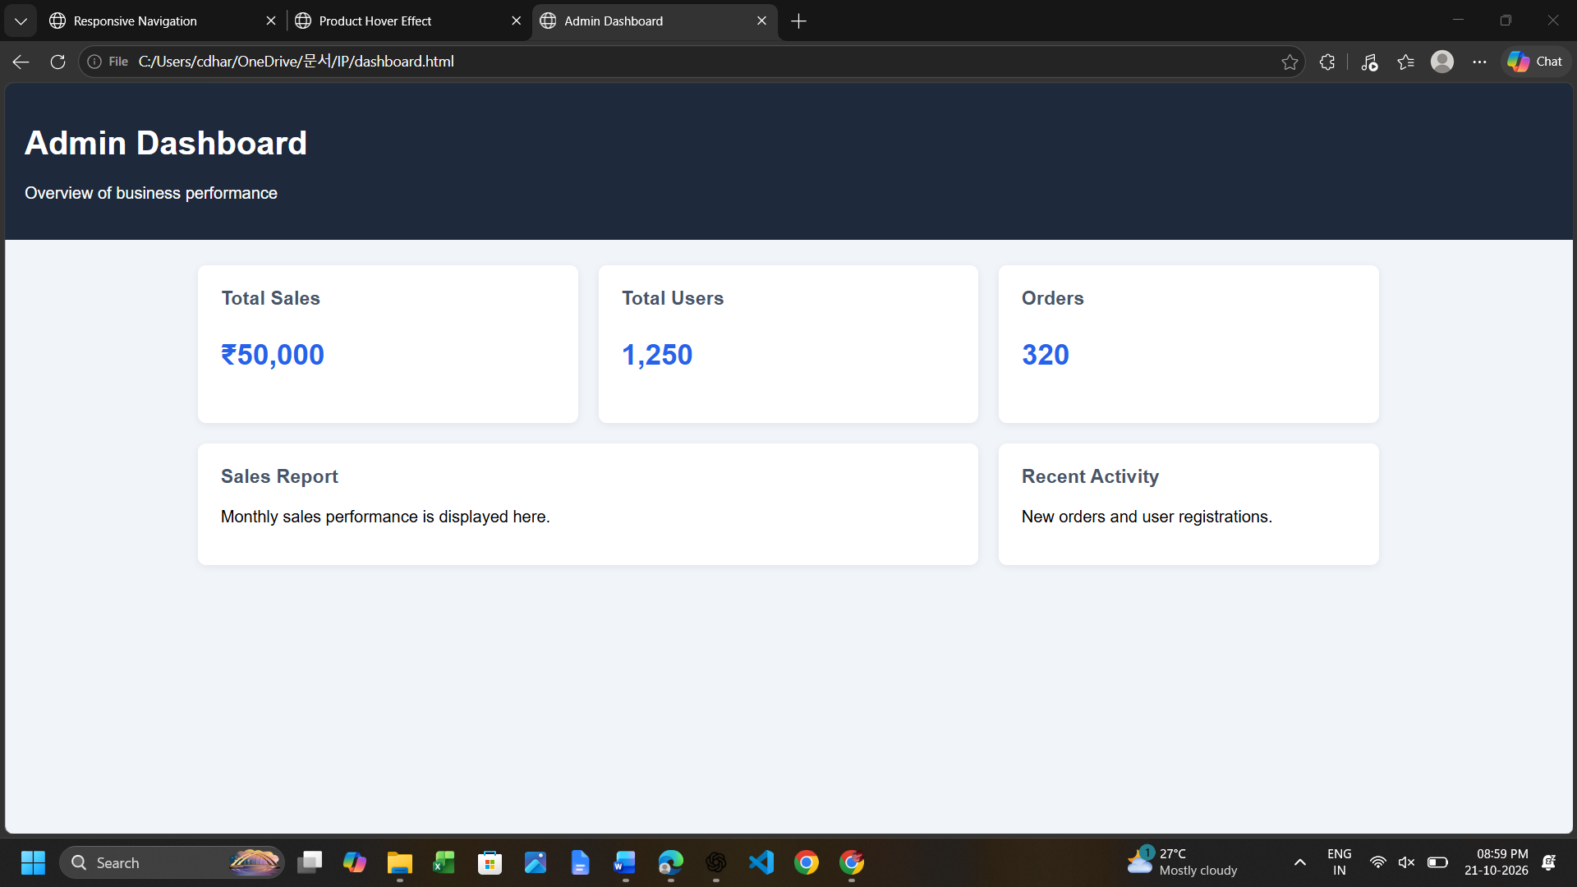

Expected Output
The dashboard displays three columns on wide screens, two columns on medium screens, and one column on narrow screens. The Monthly Performance panel spans two columns where space allows.

Result
The required webpage design and interaction are implemented using HTML, CSS, and JavaScript. The result demonstrates responsive behaviour, clear visual feedback, and appropriate usability considerations for the given scenario.

Question 4: Mobile-First Blog Layout –
Suppose that a blog page must be designed following a mobile-first approach.

(a) Identify key sections of a blog layout.
A blog generally contains a header with the site title, navigation links, a main content area, article cards or posts, optional sidebar, search or category controls, and a footer. Each article can include a title, author, publication date, short description, image, and Read More link. The layout should make the newest or most important content easy to find.

(b) Design a mobile-first layout using CSS.
A mobile-first layout begins with rules for narrow screens. The default article list uses one column, making text readable and avoiding horizontal scrolling. Use a simple font, adequate line spacing, comfortable padding, clear headings, and a content container. Semantic elements such as header, main, article, section, and footer give the page a meaningful structure.

Program
<!DOCTYPE html>
<html lang="en">
<head>
<meta charset="UTF-8">
<meta name="viewport" content="width=device-width, initial-scale=1.0">
<title>Mobile-First Blog</title>
<style>
* { box-sizing: border-box; }
body { margin: 0; font-family: Arial, sans-serif; line-height: 1.6;
background: #f8fafc; color: #1f2937; }
header { background: #0f172a; color: white; text-align: center; padding: 20px; }
.container { max-width: 1100px; margin: auto; padding: 15px; }
.blog-list { display: grid; grid-template-columns: 1fr; gap: 16px; }
article { background: white; padding: 18px; border-radius: 8px;
box-shadow: 0 2px 7px #0001; }
article h2 { margin-top: 0; }
a { color: #1d4ed8; }
a:focus-visible { outline: 2px solid #1d4ed8; outline-offset: 3px; }
footer { text-align: center; padding: 18px; background: #e2e8f0; margin-top: 20px; }
@media (min-width: 600px) {
.blog-list { grid-template-columns: repeat(2, minmax(0, 1fr)); }
}
@media (min-width: 900px) {
.blog-list { grid-template-columns: repeat(3, minmax(0, 1fr)); }
}
</style>
</head>
<body>
<header><h1>My Blog</h1><p>Ideas, learning and technology</p></header>
<main class="container">
<section class="blog-list" aria-label="Recent blog posts">
<article><h2>Learning HTML</h2><p>HTML provides the structure of a webpage using headings, paragraphs and links.</p><a href="#html">Read more about HTML</a></article>
<article><h2>Understanding CSS</h2><p>CSS controls colours, spacing, typography and responsive page layouts.</p><a href="#css">Read more about CSS</a></article>
<article><h2>JavaScript Basics</h2><p>JavaScript adds interaction such as menus, form checks and dynamic content.</p><a href="#javascript">Read more about JavaScript</a></article>
</section>
</main>
<footer>© 2026 My Blog</footer>
</body>
</html>

Code explanation
- The default layout is one column, so it is mobile-first.
- The 600px breakpoint adds a second column.
- The 900px breakpoint adds a third column.
- Semantic HTML and visible keyboard focus improve accessibility.

(c) Demonstrate how the layout scales for larger screens using media queries.
At 600px and above, the article list can display two columns. At 900px and above, it can display three columns. This progressive enhancement adds columns only when there is enough room. CSS Grid is useful because the number of columns can be changed with a small number of rules.
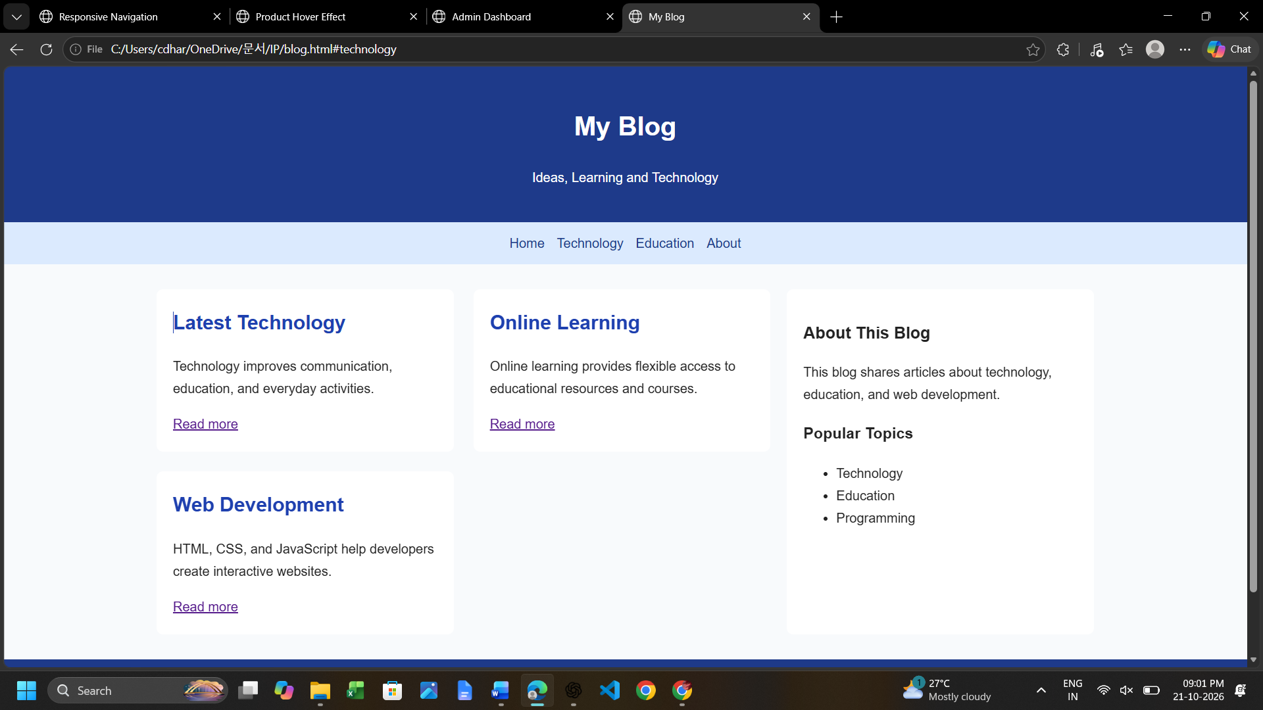

(d) Evaluate accessibility and readability of the design.
Use readable font sizes, sufficient colour contrast, descriptive links, meaningful heading order, and alt text for informative images. Ensure the page works with keyboard navigation and does not rely on colour alone to communicate information. Keep line length comfortable on desktop and avoid tiny text. Test zoom and mobile widths to ensure content does not overflow.

Expected Output
On a mobile screen, articles appear in one column; on medium screens, two columns appear; and on wide screens, three columns appear. The page retains readable text, spacing, and a clear header and footer.

Result
The required webpage design and interaction are implemented using HTML, CSS, and JavaScript. The result demonstrates responsive behaviour, clear visual feedback, and appropriate usability considerations for the given scenario.

Question 5: JavaScript Event Handling for Dynamic Menu – Marks (4)
Suppose that a website includes a dynamic menu that responds to user interactions.

(a) Identify appropriate JavaScript events for menu interaction.
The click event opens or closes the menu when the user activates the menu button. The keydown event can detect Escape and close the menu for keyboard users. Mouseover and mouseout can provide optional visual feedback, but they should not be required to open the menu because touchscreens do not always have hover. Focus events can help indicate which link is currently selected. For basic responsive navigation, click and keydown are the most useful events.

(b) Design event handling logic for menu toggle functionality.
First select the button and navigation element by their IDs. Add a click listener to the button. Inside the handler, toggle a CSS class such as open. CSS defines how the menu looks when that class is present. Update aria-expanded to reflect the current state. Keeping visual styling in CSS and interaction logic in JavaScript makes the code easier to maintain.

(c) Implement interaction for user actions (click/hover).
The program below opens and closes the menu with a click, closes it when a link is selected, and closes it when Escape is pressed. CSS hover and focus styles give feedback when users point to or keyboard-focus links.

Program
<!DOCTYPE html>
<html lang="en">
<head>
<meta charset="UTF-8">
<meta name="viewport" content="width=device-width, initial-scale=1.0">
<title>Dynamic Menu</title>
<style>
body { margin: 0; font-family: Arial, sans-serif; }
header { background: #172554; color: white; padding: 15px;
display: flex; justify-content: space-between; align-items: center; }
button { padding: 8px 12px; font-size: 18px; cursor: pointer; }
nav { display: none; flex-direction: column; background: #dbeafe; padding: 10px; }
nav.open { display: flex; }
nav a { padding: 12px; text-decoration: none; color: #172554; }
nav a:hover, nav a:focus-visible { background: #bfdbfe; }
main { padding: 25px; }
@media (min-width: 700px) {
header { justify-content: center; gap: 40px; }
button { display: none; }
nav { display: flex; flex-direction: row; justify-content: center; gap: 20px; }
}
</style>
</head>
<body>
<header>
<h2>My Website</h2>
<button id="menuButton" aria-expanded="false" aria-controls="mainMenu">☰ Menu</button>
</header>
<nav id="mainMenu" aria-label="Main navigation">
<a href="#home">Home</a><a href="#services">Services</a>
<a href="#about">About</a><a href="#contact">Contact</a>
</nav>
<main id="home"><h1>Welcome</h1><p>This page demonstrates JavaScript event handling for a dynamic menu.</p></main>
<script>
const button = document.getElementById("menuButton");
const menu = document.getElementById("mainMenu");

function closeMenu() {
menu.classList.remove("open");
button.setAttribute("aria-expanded", "false");
}

button.addEventListener("click", function () {
const isOpen = menu.classList.toggle("open");
button.setAttribute("aria-expanded", String(isOpen));
});

menu.addEventListener("click", function (event) {
if (event.target.closest("a")) closeMenu();
});

document.addEventListener("keydown", function (event) {
if (event.key === "Escape") {
closeMenu();
button.focus();
}
});
</script>
</body>
</html>

Code explanation
- addEventListener registers a function for a particular event.
- classList.toggle changes the menu state.
- closeMenu is reused for link selection and Escape.
- The aria-expanded attribute stays synchronized with the menu state.
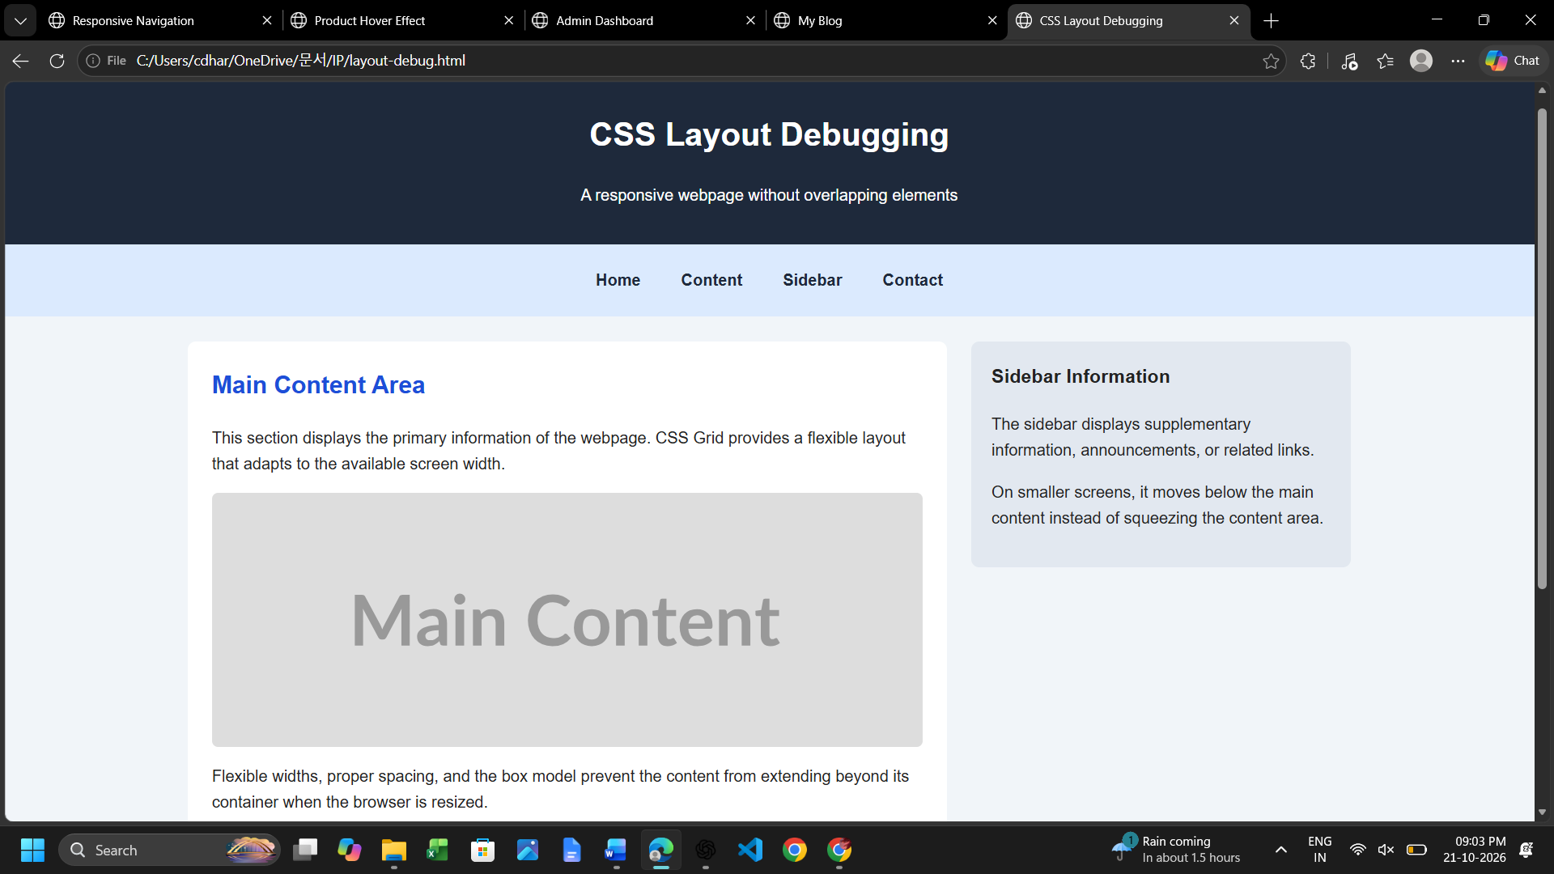

(d) Evaluate performance and suggest improvements.
Event listeners are efficient for a small navigation menu. Avoid repeatedly changing many inline styles; use CSS classes instead. Keep event logic short, update accessibility attributes, support keyboard input, and ensure menu links remain usable on touchscreens. Hover effects should be decorative rather than the only way to reveal essential options. For larger applications, close menus on route changes and consider outside-click behaviour where appropriate.

Expected Output
On narrow screens, the menu button toggles the links. Selecting a link closes the menu, and Escape closes it and returns focus to the button. On wider screens, links appear horizontally and the button is hidden.

Result
The required webpage design and interaction are implemented using HTML, CSS, and JavaScript. The result demonstrates responsive behaviour, clear visual feedback, and appropriate usability considerations for the given scenario.

